|  |
| --- |
| Circle Language Spec: Commands |

## Command References in a Command Call in a Diagram

This article demonstrates a situation of command objects.

This article illustrates how command references in a command call look in a diagram.

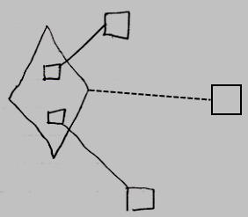

The diamond is a command call. The command call’s definition is indicated with the dashed line, pointing to the square on the right, which is the command definition. The smaller squares inside the call are command references in a command call. They are actually *public* command references. This makes the command references *parameters* of the command call. The command references have object lines, solid ones, going outside, ending at the targets of the command references.